**TRAFFIC MANAGEMENT**

**Problem overview :**

The Traffic Management Project is a critical initiative aimed at addressing the pressing issues within urban transportation and traffic control. The project is situated in [Specify Geographical Location] and responds to a range of challenges that have a significant impact on both the community and the overall transportation system. These challenges encompass problems like congestion, safety concerns, infrastructure maintenance, and environmental sustainability. The core objectives of this project are to reduce traffic congestion, enhance safety on the roadways, improve public transportation integration, and mitigate the environmental impacts associated with high traffic volumes. By employing innovative strategies, data-driven decision-making, and engaging various stakeholders, the project seeks to find effective solutions to these problems. It also necessitates the collaboration of government agencies, city officials, transportation companies, and the general public. Data collection and analysis will be central to informed decision-making, and the project must address potential challenges such as funding constraints and community resistance. A clearly defined budget and resource allocation plan, alongside a well-structured timeline, will guide the implementation process. Additionally, the project emphasizes community engagement through public consultations and feedback mechanisms to ensure it aligns with the community's needs and sustainability goals, ultimately resulting in reduced congestion, improved safety, and positive environmental impacts.

**Proposed Idea :**

Our proposed ideas for the traffic management project include implementing an intelligent traffic signal system, expanding and improving public transportation, creating multi-modal transportation hubs, maintaining and expanding roadways, developing active transportation infrastructure, considering congestion pricing, launching public awareness campaigns, utilizing data-driven decision-making, introducing smart parking solutions, enhancing emergency response plans, promoting green transportation options, and involving the community in the decision-making process. These strategies aim to reduce congestion, enhance safety, and minimize environmental impacts while ensuring a more efficient and sustainable traffic management system.

**Implementation of Our Idea :**

Integrating historical traffic data and machine learning algorithms for real-time traffic management is a powerful approach. Here are the steps to implement this idea effectively:

**1 )Data Collection and Storage:**

Collect historical traffic data from various sources such as traffic sensors, cameras, GPS devices, and public transportation systems. store this data in a structured database or a data warehouse to ensure easy access and retrieval.

**2 )Data Preprocessing:**

Clean and preprocess the historical data to remove inconsistencies, outliers, and missing values. Transform the data into a suitable format for machine learning, including time series data with relevant features.

**3 )Feature Engineering:**

Identify and engineer relevant features from the historical data that can help machine learning models make accurate predictions. These features may include traffic volume, weather conditions, time of day, and special events.

**4 )Machine Learning Model Selection:**

Choose appropriate machine learning algorithms for real-time traffic prediction and management. Time series forecasting models like ARIMA, machine learning models such as decision trees, and random forests, or more advanced techniques like deep learning with recurrent neural networks (RNNs) or Long Short-Term Memory (LSTM) networks are often effective choices.

**5 )Training the Model:**

Train the selected machine learning models using the preprocessed historical traffic data. Split the data into training and validation sets, and use techniques like cross-validation to ensure model accuracy.

**6 )Real-Time Data Collection:**

Continuously collect real-time traffic data from various sensors and sources, such as traffic cameras, GPS-enabled vehicles, and road sensors.

**7 )Real-Time Data Processing:**

Preprocess and clean the incoming real-time data to align it with the format used for historical data.

**8 )Model Integration:**

Implement the trained machine learning model within a real-time processing pipeline. Feed the real-time data into the model to make predictions, such as traffic volume forecasts, congestion predictions, or optimal traffic signal timings.

**9 )Feedback Loop:**

Continuously monitor the model's performance and accuracy in real time. Implement a feedback loop to retrain the model periodically with new historical data and updated real-time data, improving its accuracy over time.

**10 )Actionable Insights:**

Translate the model's predictions into actionable insights for traffic management. For example, adjust traffic signal timings, suggest alternative routes, or notify commuters of expected delays.

**11 )Visualization and Communication:**

Develop a dashboard or visualization tools to present real-time traffic data and insights to traffic managers, city officials, and the public. Effective communication is crucial for prompt decision-making and informed commuting.

1**2 )Scalability and Redundancy:**

Ensure the system is scalable to handle increased data volume and redundancy to handle system failures without disrupting real-time traffic management.

**13 )Community Engagement:**

The local community to provide feedback and gather their insights into traffic issues. Public involvement can help fine-tune the system and gain community acceptance.

**14) Compliance and Privacy:**

Ensure compliance with data privacy regulations when collecting and processing data, especially real-time data from vehicles and pedestrians.

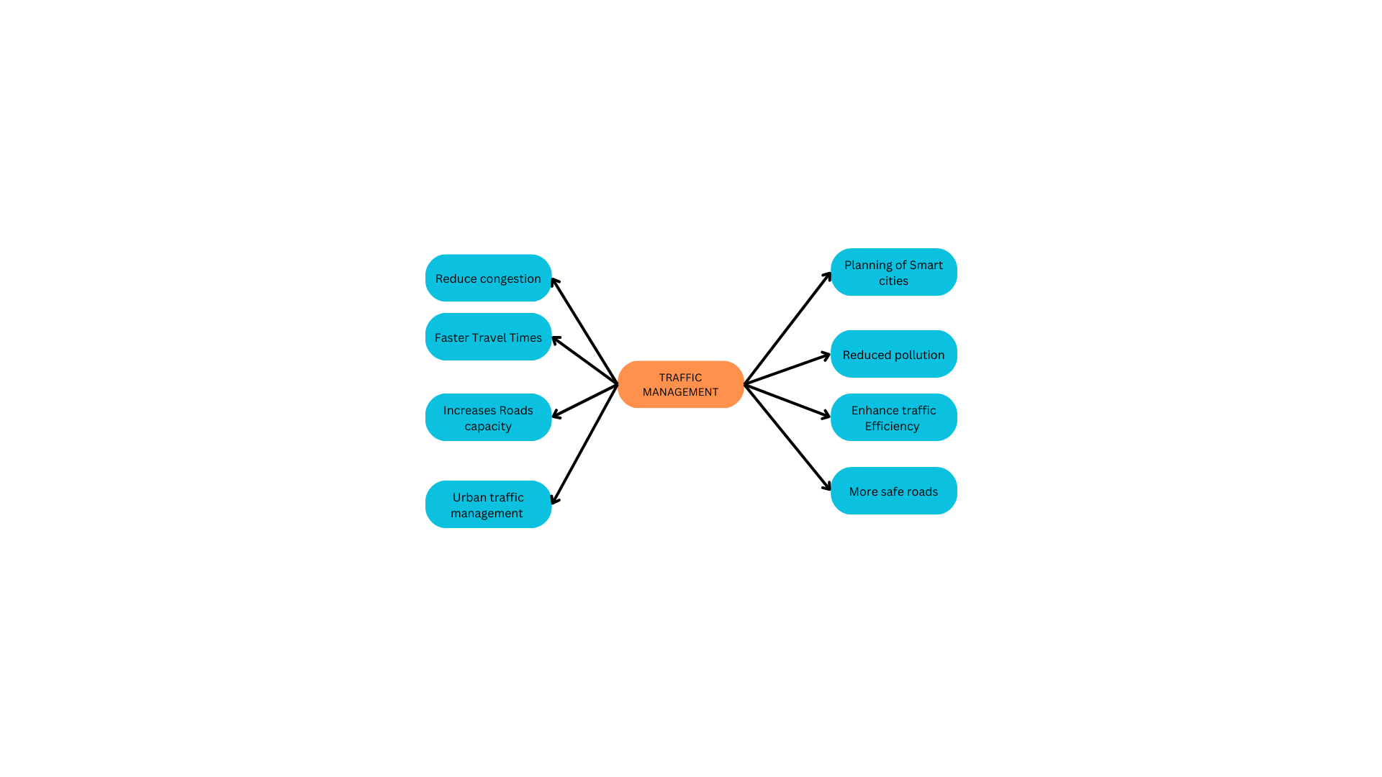

**Conclusion:**

Implementing historical traffic data integration with machine learning algorithms in real-time traffic management requires a robust infrastructure, continuous monitoring, and a feedback loop to adapt to changing traffic conditions. When effectively implemented, it can significantly improve traffic flow, reduce congestion, and enhance overall transportation efficiency.